vision
Pitt County Schools, A system of excellence partnering with family and community to prepare students to function effectively in a rapidly changing world by developing global citizens through academic excellence.
As occupational therapists, we envision a community that respects, values, celebrates, and supports individual differences in education, and where students with disabilities are enabled to become contributing members of their community.

MISSION
The Exceptional Children’s Program of Services and Staff commits to providing specially designed instruction with fidelity and evidences based practices to students with disabilities with IEP’s enrolled in Pitt County Schools in the least restrictive educational environment.
As occupational therapists, our goal is to maximize the disabled student’s ability to independently and successfully participate in the educational process through the use of targeted, therapeutic activities, adaptation of the student's environment, and training and consultation with staff and families.

Contact us
The Occupational Therapy Team office is located at:
1058 Moye Blvd. Greenville, NC 27858
Please Contact Joi Hadnott, OTR/L
Lead Occupational Therapist regarding any questions/concerns for your student.
Phone: 252-830-3557
E-mail: hadnottj@pitt.k12.nc.us

school-based Occupational therapists
Therapist Name:

Schools Served :

E-mail :

Pitt County Public Schools
Exceptional Children’s Programs

OCCUPATIONAL THERAPY
Skills for the Job of Learning

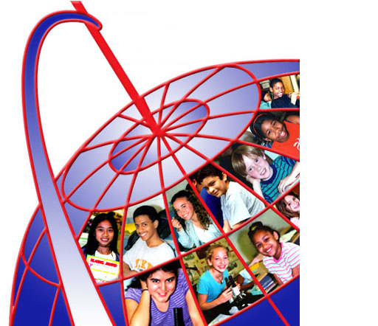

PITT COUNTY SCHOOLS
Exceptional Children’s Programs

how does occupational therapy support the job of learning?
Occupational therapy practitioners in schools focus on a child’s ability to participate in the following occupations:
Personal Care (feeding, toileting, dressing, hygiene, managing personal belongings, personal organization)
Student role/Interaction Skills (following protocols & routines in the classroom, specials, campus, bus, cafeteria; exercising safety awareness; respecting the space/time/materials of others; negotiating relationships with peers & staff)
Learning academics/Process skills (following demonstrations, copying models, carrying out verbal directions, attending to instruction, using classroom tools, completing assignments)
Play (turn-taking, imaginative play, sharing materials, exploring new play ideas/opportunities)
Community Integration/Work (fieldtrips, school-related vocational training, community mobility)
Graphic communication (handwriting, keyboarding, drawing, producing artwork)

who receives occupational therapy in schools?
Occupational therapy (OT) is a related service under Part B of the Individuals with Disabilities Education Act (IDEA), and is provided to help a student with a disability to benefit from special education. As such, OT is a supportive service. If a child has a disability, as defined by IDEA, and needs special education and related services to meet unique learning needs, then he/she might be eligible for OT services. The child must be eligible for special education before being considered for OT services in the schools under IDEA. Referral for an OT evaluation is a team decision. Eligibility for special education does not mean automatic eligibility for related services, including OT services.
Occupational therapy services are provided in schools by qualified, licensed occupational therapists and occupational therapy assistants. The Pitt County Schools Occupational Therapy team boasts over 183combined years of experience in OT practice, with the majority of years of experience in the field of school based practice.
Under Section 504 of the Rehabilitation Act of 1973, a disabled student may be eligible to receive OT when a physical or mental impairment substantially limits one or more major life activities. Major life activities include caring for oneself, performing manual tasks, walking, talking, seeing, hearing, speaking, breathing, working, and learning.

what services do occupational therapy practitioners provide?
Occupational therapy practitioners are trained to assess and treat occupational performance problems in the environment where these occupations are being done. For children, school is one of the primary environments where the occupations of personal care, learning, and playing are engaged. In the context of interdisciplinary school-based teams, occupational therapy practitioners:
participate in the referral process
conduct evaluations
help determine eligibility
help create student goal plans
provide intervention
chart & communicate progress
re-evaluate
help determine need to terminate service
Occupational therapy practitioners intervene with students by providing direct service (one-on-one or in groups,) consultation, and monitoring based on the student’s goal plan. Therapists may help make modifications to a student’s environment, activities, or assignments in order to increase participation. Intervention occurs in the student’s least restrictive environment, which usually means integrating therapy into the student’s classroom schedule or daily routine.

